Batch: B2 Roll No:1611103
Experiment No. 10
Grade: AA / AB / BB / BC / CC / CD /DD

Title: Implementation of priority queue program using heap.

Objective: To implement the concept of priority queue by creating a heap consisting of numbers input by the user.

Expected Outcome of Experiment:

CO | Outcome
2 | Use linear and non linear data structure in domain like compiler construction, DBMS etc.

Books/ Journals/ Websites referred:

Abstract:- In this program for a given number of elements input by the user a heap is to be created in which every parent has a value greater than its children. This max heap is then used to implement priority queue by removing the root of the heap which will be the element of highest priority (greatest value) and then rearrange the rest of the heap.

Related Theory: -
HEAP:
A heap is a specialized tree-based data structure that satisfies the heap property: if P is a parent node of C, then the key (the value) of P is either greater than or equal to (max heap) or less than or equal to (min heap) the key of C. The node at the "top" of the heap (with no parents) is called the root node.
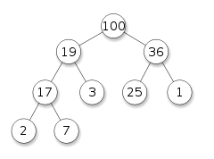

Related Theory (contd...): -

PRIORITY QUEUE:
A priority queue is an abstract data type which is like a regular queue or stack data structure, but where additionally each element has a "priority" associated with it. In a priority queue, an element with high priority is served before an element with low priority. If two elements have the same priority, they are served according to their order in the queue.
While priority queues are often implemented with heaps, they are conceptually distinct from heaps. A priority queue is an abstract concept like "a list" or "a map"; just as a list can be implemented with a linked list or an array, a priority queue can be implemented with a heap or a variety of other methods such as an unordered array.

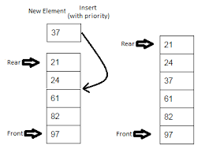

Implementation Details:
1. Enlist all the Steps followed and various options explored
2. Explain your program logic, classes and methods used.
3. Explain the Importance of the approach followed by you

STEPS FOLLOWED:
- STEP 1: Store values input by the user.
- STEP 2: Arrange the values to form a max heap.
- STEP 3: Define function that will remove the maximum value element form the heap and rearrange the heap.
- STEP 4: STOP.

PROGRAM LOGIC:
- Take input values from the user and store them in an array.
- Define a function that creates a heap from the input data:
  - Call this function for non leaf nodes and send the value and the position in the array.
  - For given position, find out the greatest valued children that that particular position has.
  - Compare the greatest valued child with the value stored at the position.
  - If child has greater value, swap the values of the parent and the child, and perform the above steps again w.r.t. the position of the child.
  - Else break from the loop.
  - Perform above steps till the position being checked is less than or equal to half of the number of inputs.
- In the delete function:
- Retrieve the root value of the heap. Replace this root value by the value of the rightmost leaf node and delete this node.
- Perform step 2 w.r.t. position of root node so that the disturbed heap is rebalanced.
- The value that was retrieved will be the element with the highest priority (in this case the greatest number).
- Stop.

IMPORTANCE OF APPROACH:

Use of arrays makes creation and storing of heaps easier, and clashing of data for a particular location does not take place since for a particular location p, the left child will always be stored at location 2*p and right child at location 2*p+1. With the help of max heap the element with the highest priority is always at the root and thus to obtain the highest priority element one only needs to extract the root of the heap. When the root is removed the heap rearranges itself to give the next highest priority element at the root. Thus heaps can efficiently implement priority queue.

IMPLEMENTATION DETAILS:
PROGRAM:
#include<stdio.h>
#include<stdlib.h>
#include<conio.h>
#define MAX 100

void restoreBelow(int pos,int arr[],int n)
{
int val;
int i;
val=arr[pos];
while(pos<=(n/2))
{
i=2*pos;
if((i<n) && arr[i]<arr[i+1])
i++;
if(val >= arr[i])
break;
arr[pos]=arr[i];
pos=i;
}
arr[pos]=val;
}

void makeHeap(int arr[],int n)
{
int i;
for(i=(n/2);i>=1;i--)
restoreBelow(i,arr,n);
}

int del(int arr[],int n)
{
int val;
val=arr[1];
arr[1]=arr[n];
n--;
restoreBelow(1,arr,n);
return val;
}

void display(int arr[],int n)
{
int i;
for(i=1;i<=n;i++)
printf("%d ",arr[i]);
}

void insert(int arr[],int *n)
{
int ele;
printf("\nEnter the element to be inserted : ");
scanf("%d",&ele);
(*n)++;
arr[*n]=ele;
makeHeap(arr,*n);
printf("The heap after insertion is:-\n");
display(arr,*n);
}

void main()
{
int ch,heap[MAX],data,i;
int n=0,k=0;
clrscr();
printf("Enter the number of elements : ");
scanf("%d",&n);
heap[0]=0;
for(i=1;i<=n;i++)
{
printf("\nEnter the elements: ");
scanf("%d",&heap[i]);
}
display(heap,n);
makeHeap(heap,n);
display(heap,n);
do
{
printf("\n-----------------MENU---------------");
printf("\n1.Insert\n2.Delete\n3.Quit");
printf("\nEnter the choice:- ");
scanf("%d",&ch);
switch(ch)
{
case 1 :
insert(heap,&n);
break;
case 2 :
k=del(heap,n);
printf("\nThe element deleted is %d\n",k);
makeHeap(heap,n);
printf("The heap after deletion is:-\n");
display(heap,n);
break;
case 3 :printf("Finalising data......\n");
printf("The heap is:-\n");
display(heap,n);
printf("Thank You.\nVisit Again!!!!\n");
break;
default: printf("Input error.Try again.\n");
break;
}
}while(ch != 3);
}
OUTPUT:

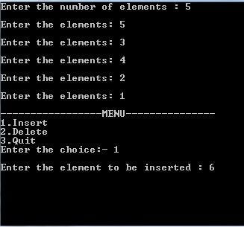

Conclusion:-hence, priority queue was successfully implemented using max heap.

